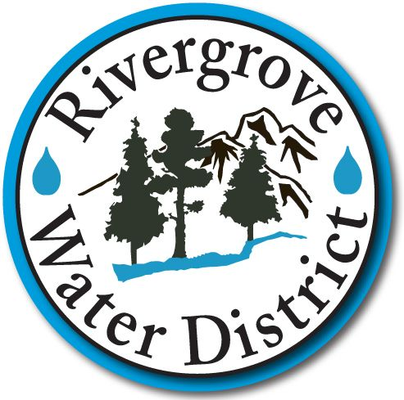
PUBLIC INFORMATION/RECORDS REQUEST
The definition of a Public Record and the rules regarding their release are set forth in ORS 192.410 through 192.505 and in the Oregon Attorney General’s Public Meetings and Records Manual. Although public records are usually disclosable, there are a number of limited circumstances under which a public body either must or may decline to release certain information.

Please provide the following information in order to process the request:
Requestor’s Identity:

Date: _____________________________________________________

Name:

Address:

Phone/email address:

Signature:

Requested Information/Records(s): Please give a brief statement describing the requested information/records(s) being specific in order for the District to determine the nature, content and probable department within which the record(s) you are requesting may be located.

Purpose of Request: Because the identity and motive of the person seeking the disclosure of a particular public record may be relevant in determining whether a record is exempt from mandatory disclosure under a conditional exemption, please give a brief statement as to the purposes of your request:

Routine requests will be handled within the Administration Department. More complex written requests or requests that implicate application of statutory exemption from disclosure shall be submitted to the District’s Legal Counsel for response. Legal Counsel’s response will be pursuant to the District’s policy, adopted by Resolution 2015-5. A copy of such resolution is available for review. In most cases, there will be a fee charged for providing service. Payment for meeting the request must be received prior to the requested materials being released. The Finance Manager will advise you of the fee(s) required for your request.

Date Processed: Approved By __________________________________
# of Copies: @ = _____
Staff Time: hours@ = _____
Total Paid: $ _______________

