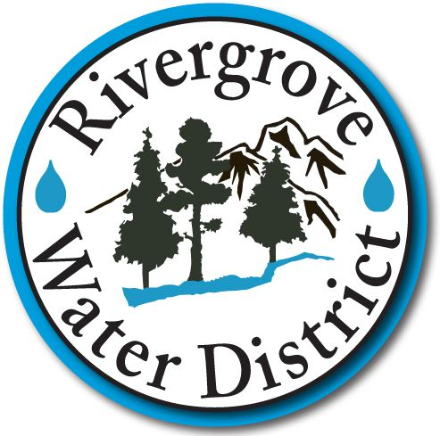

APPLICATION FOR EMPLOYMENT

Thank you for considering Rivergrove Water District in your job search. Rivergrove Water District is an equal employment opportunity employer and does not discriminate on the basis of sex, age, race, color, religion, national origin, mental or physical disability, marital status, uniformed services status or any other classification protected by law. No application will be rejected as a result of a disability that, with reasonable accommodation, does not prevent performance of the essential job duties.

CONFIDENTIAL
Please complete by printing in dark ink.
Complete all questions, and sign your initials and name on the last page where indicated.

Date
Personal Information
Last Name | First Name | Middle Initial
Street Address | City and State | Zip Code
Home Phone | Work Phone | Date You Can Begin
E-mail Address | Position Applied For | Salary Desired
 |  | Hourly or Annually

Level and Type of Education | School Name | City and State | Last Year Completed | Did You Graduate?
High School |  |  | 9 11  10 12 | Yes  No
College or University |  |  | < 1 Year  1 2  3 4 | Degree
Additional Schooling |  |  | Number of Years: | Certificate or License

Special Skills
Software Applications:

Other Skills:

Employment Record

Please list your most recent jobs first. Include military service as part of your employment record. If you have a resume, please attach it to this form.

Employer | Address
Telephone Number | Supervisor’s Name
Job Title | Dates of Employment (month and year)
 | From: To:
Reason for Leaving | Essential Job Duties

Employer | Address
Telephone Number | Supervisor’s Name
Job Title | Dates of Employment (month and year)
 | From: To:
Reason for Leaving | Essential Job Duties

Employer | Address
Telephone Number | Supervisor’s Name
Job Title | Dates of Employment (month and year)
 | From: To:
Reason for Leaving | Essential Job Duties

General Information
May we contact your present employer? | Yes No
Do you have the legal right to work in the United States?  (If hired, you will be required to provide identification to prove eligibility for employment) | Yes No
Have you been employed or attended school using any other name? If yes, please indicate names previously used: | Yes No
Are you able to perform the primary duties of the job as outlined in the newspaper advertisement, announcement, posting, job line, job description, with or without reasonable accommodation?  If no, please explain: | Yes No
Do you have any employment restrictions resulting from a non-compete or confidentiality agreement?  If yes, please explain: | Yes No

Additional Information
Please use the space provided to list any additional employers, periods of time not worked, or any other information that you believe we should know in considering your application for employment.

Please read carefully, initial each paragraph and sign below

I certify that I have answered the above questions truthfully and have not withheld any information relative to my application. I understand that any falsification, misrepresentation, or omission, as well as any misleading statements or omissions of the application information, attachments, and supporting documents generally will result in denial of employment or immediate termination, if discovered after hire.

I authorize Rivergrove Water District to thoroughly investigate my references, work record, education, and other matters related to my suitability for employment, and further authorize the references I have listed to disclose to the company any and all letters, reports, and other information related to my work records, without giving me prior notice of such disclosure. In addition, I release Rivergrove Water District, my former employers and all other persons, corporations, partnerships and associations from any and all claims, demands, or liabilities arising out of or in any way related to such investigation or disclosure.

I authorize Rivergrove Water District to investigate whether I have a criminal record of convictions, and, if so, the nature of such convictions and all the surrounding circumstances of the conviction. Rivergrove Water District has advised me that any criminal background check will focus on convictions, and that a criminal record will not necessarily disqualify me from employment.

If hired, I recognize the rules and policies of Rivergrove Water District. I understand that my employment and compensation can be terminated at any time, with or without cause, and with or without notice, at the option of Rivergrove Water District or myself. I understand that the Rivergrove Water District Board of Commissioners have the authority to create any other terms of employment and/or to enter into any employment contract and that all such contracts must be in writing and signed by both parties. However, I also understand that unless otherwise stated in an employment contract, the company may change, withdraw, and interpret other policies (including wages, hours and working conditions) as it deems appropriate.

I understand and acknowledge that I may be required to submit to a physical examination, including drug test. Additionally, I hereby authorize the release of the results of such an examination Rivergrove Water District for their use in evaluating my suitability for employment. Further, I release the examining facility and Rivergrove Water District from any and all liability, and from any damage that may result from the release of such information.

Signature
_____________________________
Date
_____________________________
Printed Name

Important Information to Know Before Filling Out

An Application for Employment with Rivergrove Water District

- All areas of the application must be filled out completely and accurately. Please fill in the required information directly on the application and do not indicate “see resume.”

- If you are offered a position with Rivergrove Water District be aware that we may verify all of the information that you have written on the application, as well as your resume. If there is a discrepancy in your information, the job offer may be withdrawn. It is important to be sure that what you have written is correct.

3. If you have any questions about completing the application, it is important to please ask the Rivergrove Water District representative who has been assisting you.

Thank you for your cooperation.

Applicant Acknowledgement:

My signature below indicates that I have read and understand the importance of supplying accurate information on the application. I am also aware of the possibility of an offer of employment being withdrawn if any of the information is not correct.

Applicant Signature Date

